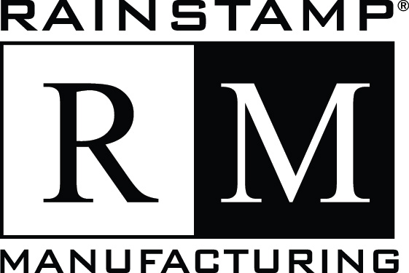

50 YEAR PAINT WARRANTY
PRORATED, LIMITED
RainStamp Corporation (“RainStamp”) provides the following warranty for RainStamp painted aluminum gutter products:
- Who is covered under this warranty?
RainStamp extends this warranty to the original purchaser of all RainStamp painted aluminum gutter products installed on real property owned by the original purchaser.
- What does this warranty cover?
RainStamp warrants that its painted aluminum gutter products will be free of painting defects when properly formed and installed, subject to the limitations and conditions set forth in this warranty. This warranty covers only genuine RainStamp painted aluminum gutter products, and only covers defects to the original factory finish that are attributable to the painting process, such as: cracking, peeling, or chipping.
RainStamp will assume 100% of the cost of refinishing or replacement of the defective material only during the first year. RainStamp’s liability shall decline by 25% per annum through the fourth year and ½% per annum thereafter through the fiftieth year. RainStamp’s liability shall not decline to less than 1% of the cost of refinishing or replacement during the 50th year. The basis for computing the cost shall be retail prices at the time of refinishing or replacement. The owner’s share of the refinishing or replacement cost, if any, will be computed by RainStamp utilizing the pro-rata terms and provisions of this warranty. An invoice for such amount will be prepared and sent to the owner, in duplicate. The owner, by signing one copy of the invoice and returning it to RainStamp’s Warranty Division along with a cashier’s check for the amount shown thereon, will authorize RainStamp to proceed. RainStamp’s obligation under this warranty shall at no time exceed the original purchase price of the products at the time of installation.
- What does this warranty not cover?
Defects not covered are those that result from normal weathering, product handling before or during installation, faulty installation, uses other than the designed function including but not limited to roofing, under decking, or trim, any change or distortion of the original attaching structure, or any other thing beyond RainStamp’s control such as: accidental damage, fire, ice, hail, lighting, winds, tornadoes, hurricanes, earthquakes, acts of God, vandalism, war, chemicals in the air (tiger striping), water or ground, fungus, mildew, damage due to seawater/saltwater exposure, runoff from algae-resistant roof shingles, lack of yearly cleaning or improper cleaning. This warranty is valid only if genuine painted aluminum gutter products supplied by RainStamp are used and shall be void if painted aluminum gutter products not supplied by RainStamp are used which cause defects to occur in the paint of the RainStamp painted aluminum gutter products.
- What is the period of coverage?
This warranty becomes effective from the date of the original installation of the products and is for a period of 50 years.
- What will we do to correct problems covered by this warranty?
Should, during the warranty period, the RainStamp painted aluminum gutter products be found to have painting defects, RainStamp will, upon notification and validation of the complaint by physical inspection, either repair, refinish, or replace, at its option, the defective products, subject to the limitations and conditions set forth in this warranty.
Your exclusive remedy shall be repair, refinishing, or replacement solely at RainStamp’s option and only on the terms stated in this warranty.
- What will we not do under this warranty?
RainStamp maintains the right to change or discontinue any of its products without notice or liability under this warranty. If the products covered by this warranty are no longer available at the time a claim is made, RainStamp retains the right to substitute a product of similar or greater quality or value.
- How do you get service?
All claims must be submitted in writing to RainStamp promptly after discovery of the claimed defect and during the warranty period. Claims should include the name, address and phone number of the purchaser, date of purchase, name of the installing contractor and proof of purchase. All claims should be mailed to: RainStamp Corporation, Attn: Warranty Dept, 15409 Long Vista Dr, Austin, TX 78728.
- What must you do to keep the warranty in effect?
This warranty shall remain in effect only if the painted aluminum gutter products are cleaned on an annual basis in accordance with the instructions included with this warranty. The guarantee shall be null and void if harmful cleaning compounds are used resulting in damage to the finish that subsequently cause a defect.
- How does state law relate to this warranty?

This warranty gives you specific legal rights, and you may also have other rights which vary from state to state. Some states do not allow limitations on how long an implied warranty lasts or the exclusion of limitation of incidental or consequential damages, so the above limitations or exclusions may not apply to you.
Other limitations and conditions
RainStamp reserves the right to withdraw this warranty from the market at any time without notice. Any and all warranties in effect at the time of removal will not be affected by the withdrawal and will remain in effect until their expiration.
RainStamp cannot and will not be liable for a breach of any written or oral express warranties such as those given you by a RainStamp dealer, franchisee, or applicator of any RainStamp painted aluminum gutter products. RainStamp is liable for any guaranty or warranty for merchantability and fitness for any particular purpose for a period of only one year from the date of installation. Rain Stamp shall not be liable for injury to persons or damages to building contents, or for incidental, special, or consequential damages for breach of any written or implied warranty on all painted aluminum gutter products and workmanship.

